**SET-A**

**Rules & regulations for BTEST**

1. Immediately fill in the particulars on this page of the Test Booklet with **Ball Point Pen only**.

2. The Answer Sheet (OMR) is provided separately. Please fill in the particulars carefully with Ball Point Pen.

3. The test is of 3 hours duration.

4. The Test Booklet consists of 75 questions. The maximum marks are 300.

5. There are three parts in the question paper consisting of Physics (Q.no 1 to 25), Chemistry (Q.no. 1 to 25) and Mathematics (Q.1 to 25). Each part is divided into two sections, Section-I consists of **20 multiple choice questions** & Section-II consists of **5 Numerical Type** questions. Answer will be between 00 to 99.

**Main Pattern**

|  |  |  |  |
| --- | --- | --- | --- |
| **Part** | **Section-I**  **MCQ Type** | **Section-II**  **Numerical Type** | **Total** |
| **Physics** | **20** | **5** | **25** |
| **Chemistry** | **20** | **5** | **25** |
| **Mathematics** | **20** | **5** | **25** |
| **Total** | **60** | **15** | **75** |

6. There will be only one correct choice in the given four choices in Section-I. For each question **4 marks** will be awarded for correct choice, **1 mark** will be deducted for incorrect choice and zero mark will be awarded for unattempted question. For section-II **4 marks** will be awarded for correct answer and **1 mark** will be deducted for incorrect and zero for unattempted question.

7. No candidate is allowed to carry any textual material, printed or written, bits of papers, tablet, mobile phone, any electronic device, etc. inside the examination room/hall.

8. Rough work is to be done on the additional sheets provided

9. On completion of the test, the candidate must immediately hand over the Answer Sheet to the Invigilator on duty in the Room/Hall. However, the candidates are allowed to take away this Test Booklet with them.

10. Do not fold or make any stray mark on the Answer Sheet.

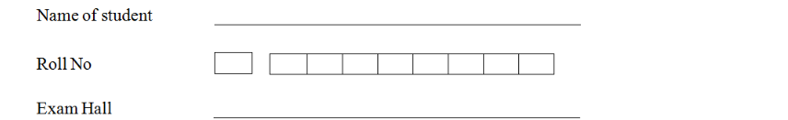

**PHYSICS**

**SECTION - I**

**Single Correct Answer Type**

This section contains 2**0 multiple choice questions**. Each question has four choices (A), (B), (C) and (D) out of which **ONLY ONE is correct. (+4, -1)**

Q.1 A Capacitor stores charge when connected across a battery. When the gap between the plates is filled with a dielectric, a charge of flows through the battery, the dielectric constant of the material inserted is  
 (A) 5 (B) 2 (C) 3 (D) 4

Solution : (C)

Given CV

Q.2 A capacitor is connected to a battery. The force of attraction between the plates when the separation between them is halved is  
(A) Remains the same (B) Becomes two times

(C) Becomes eight times (D) Becomes four times

Solution : (D)

Initial capacitance: .

When separation is halved (), new capacitance:

Since the capacitor is connected to a battery (constant voltage ), the charge becomes:

Force between the plates is given by:

New force:

Answer: (D) Becomes four times.

Q.3 A flat air capacitor consists of two large plates that are close to each other. Initially, one of the plates was not charged, while the other had charge . If entire space between the plates is filled with a slab of finite electrical resistance, estimate total amount of energy lost in the slab.  
(A) (B) (C) (D)

Solution : (B)



When a finite resistance is kept inside, it lets charge on the inner surfaces flow though it and neutralize itself.

Con of energy P.E in the capacetor.

Q.4 In the circuit shown, after the switch is shifted to position 2 the heat generated in resistance is 7.5 J. Find the EMF of the cell.

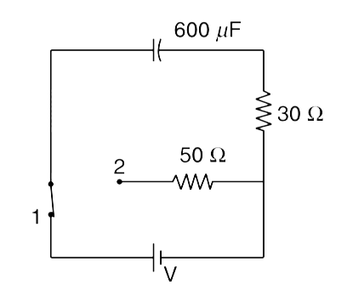

(A) 200 V (B) 460 V (C) 400 V (D) 180 V

Solution : (A)

Q.5 Consider the loop PQRSP, carrying clockwise current , shown in the figure. The magnitude of magnetic field at the centre O of the curved portion is

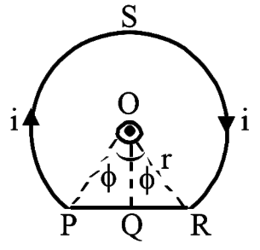

(A) (B)   
 (C) 0 (D)

Solution : (A)





Q.6 The straight long conductors AOB and COD are perpendicular to each other and carry current and . The magnitude of the magnetic induction at point P at a distance a from the point O in a direction perpendicular to the plane ACBD is

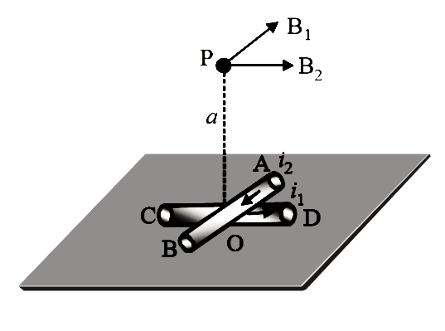

(A) (B) (C) (D)

Solution : (C)

Q.7 A wire of length L carrying current I is bent into a circle of one turn. The field at the center of the coil is . A similar wire of length carrying current is bent into a square of one turn. The field at its center is . Then

(A) (B) (C) (D)

Solution : (D)

 

Q.8 A particle of mass and charge is in an electric and magnetic field given by

The charged particle shifted from the origin to the point along a straight line path. The magnitude of total work done is.  
(A) (B) 0.25q (C) (D)

Solution : (C)

Work is done only by electric field

Q.9 Find the magnitude of the magnetic induction B of a magnetic field generated by a system of thin conductors along which a current i is flowing at a point , that is the centre of a circular conductor of radius . The ring is in plane.

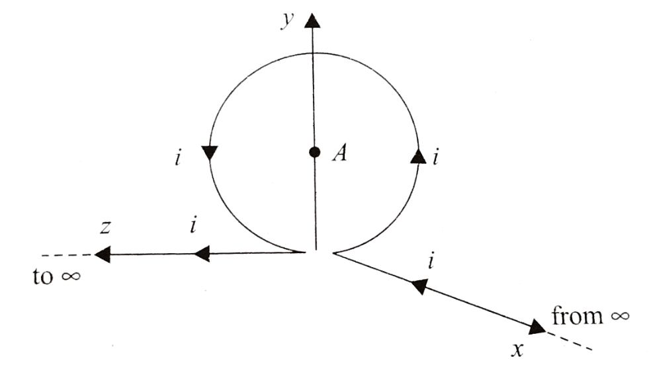

(A) (B)   
(C) (D) None of these

Solution : (B)

due to wire along -axis  
 due to loop.

due to wire along -axis

Q.10 For if, the magnetic field at point will be zero when

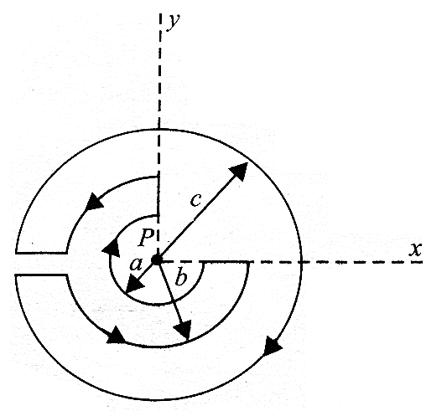

(A) (B) (C) (D)

Solution : (C)

Q.11 Find the magnitude and direction of magnetic field at point due to the current carrying wire as shown in figure.

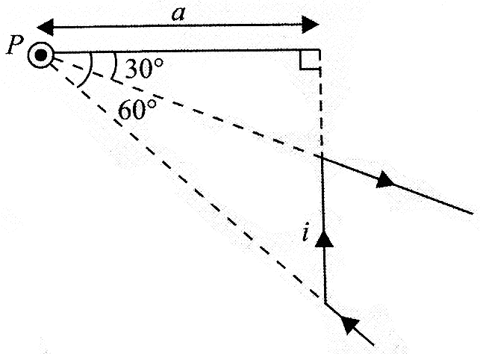

(A) (B) (C) (D)

Solution : (B)

Q.12 A particle of mass and charge is thrown from origin at with velocity units in a region with uniform magnetic field units. After time , and electric field is switched on such that particle moves on a straight line with constant speed. May be:  
(A) units (B) units (C) units (D) units

Solution : (C)





Q.13 Figure shows a vertical force F that is applied tangentially to a uniform cylinder of weight . The coefficient of static friction between the cylinder and all surfaces is 0.5. Find in terms of W, the maximum force that can be applied without causing the cylinder to rotate.



(A) (B) (C) (D)

Solution : (D)



… (1)

Q.14 A Particle having mass 2 KG is moving along straight line with speed . Find angular momentum of the particle about origin. and are in metres.  
 (A) (B) (C) (D)

Solution : (A)

Q.15 Figure shows a rough track, a portion of which is in from of a cylinder of radius . With what minimum linear speed should a sphere of radius be set rolling on the horizontal part so that it completely goes round the circle on the cylindrical part.

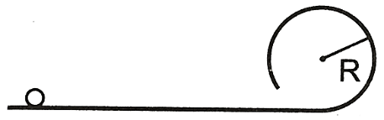

(A) (B) (C) (D)

Solution : (D)

Q.16 A cylinder rolls up an inclined plane, reaches some height and then rolls down (without slipping throughout these motions). The directions of the frictional force acting on the cylinder are:  
 (A) Up the incline while ascending and down the incline while descending  
 (B) Up the incline while ascending as well as descending  
 (C) Down the incline while ascending and up the incline while descending  
 (D) Down the incline while ascending as well as descending.

Solution : (B)

Angular velocity car only be changed because of torque due to friction.

While going up ' ' has to decrease.

Torque due to friction is opposite to ' ' and therefore upwards.  
Similarly, while coring down, w has to increase and so friction is upwards again.

Q.17 Water flows out of a big tank along a tube bent at right angles; the inside radius of the tube is equal to . The length of the horizontal section of the tube is equal to . The water flow rate is . Find the moment of reaction forces of flowing water, acting on the tube's walls, relative to the point O. density of water

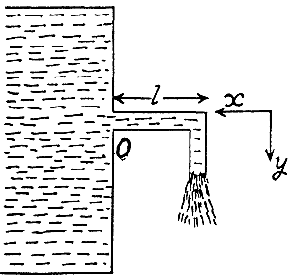

(A) (B) (C) (D) None of these.

Solution : (B)



Toque about '

Q.18 A vessel with liquid of density ' ' falls with acceleration . Find the pressure in the vessel as a function of depth ' '. Given atmospheric pressure.  
 (A) (B) (C) (D)

Solution : (D)

Theoretical

Q.19 A piece of ice floats in a vessel with water above which a layer of lighter oil is poured. What happens to the level of oil and level of water in the vessel when the ice completely melts.  
 (A) level of both oil and water increases.  
 (B) level of oil increases and level of water remains same.  
 (C) level of oil decreases and level of water increases.  
 (D) level of water increases but level of oil remains same.

Solution : (C)

Overall volume of the system decreases when ice melts. So oil level drops. When oil is poured ice cube raises and water level falls. So when ice melts the water level rises again.

Q.20 Incompressible fluid of negligible viscosity is pumped at a volume flow rate Q through a small hole into the narrow gap between two clearly spaced parallel plates as shown. The liquid flowing away from the hole only has radial motion. Find the speed as a function of radius from the hole. Separation between the plates is ' '.



(A) (B) (C) (D)

Solution : (D)

**SECTION - II**

**Numerical Type**

This section contains **5 Numerical Type questions**. **(+4, -1)**

**Answer will be between 00 to 99**

Q.21 A parallel plate capacitor which is disconnected is at a certain potential difference. When a 3 mm thick dielectric slab is introduced between the plates, the plate separation has to be increased by 2 mm in order to maintain the same potential difference between the plates. Find the dielectric constant of the slab.

Solution : (3)

Q.22 A slender rod of length forming an angle theta with the horizontal strikes, a friction less floor at A with its centre of mass velocity Vc and no angular velocity. Assumed that the impact at A is perfectly inelastic, find the angular velocity of the rod immediately after the impact.

Given :



Solution : (4)



Q.23 Find the magnetic field due to current i flowing in an elliptical loop at it's focus. The equation of ellipse (in polar coordinates as shown) is . Here e is eccentricity which is a constant. Take , if your answer is , fill n in OMR sheet.

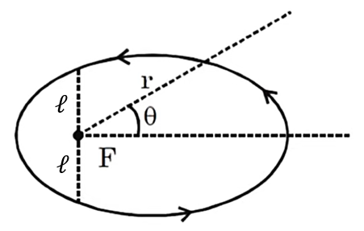

Solution : (8)

 

from sine-role



Q.24 A uniform conducting wire has a mass of 10 g. A current of 2A flows through it. The wire is kept in a uniform magnetic field . The acceleration of the wire is . Find ' '?

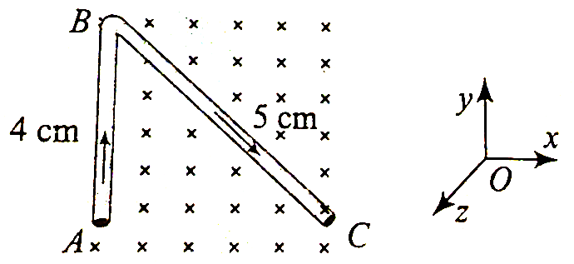

Solution : (6)

Q.25 Two parallel long wires carry currents . When the currents are in the same direction, the magnetic field midway between the wires is . When the direction of is reversed, it becomes . If the ratio where ' ' and ' ' smallest integers, find .

Solution : (8)

**CHEMISTRY**

**SECTION - I**

**Single Correct Answer Type**

This section contains 2**0 multiple choice questions**. Each question has four choices (A), (B), (C) and (D) out of which **ONLY ONE is correct. (+4, -1)**

**Atomic mass is given in brackets for the element**

**STP = (1 atm, 273K)**

**[H(1amu), C(12amu), N(14amu), O(16amu), Na(23amu), Mg(24amu) Al(27amu), P(31amu), S(32amu), Cl(35.5amu), K(39amu), Ca(40amu)]**



Solution : (A)

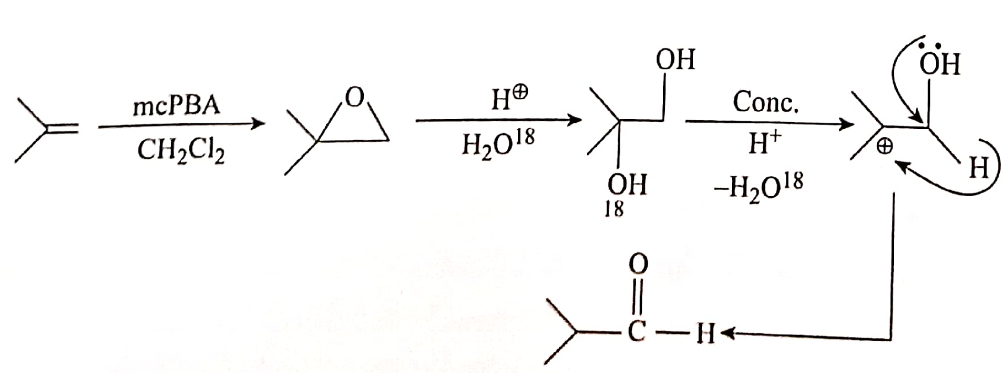

Q.2 Point out the correct statements amongst the following

(A) has tetrahedral geometry and hybridization

(B) is octahedral and Ni has hybridization

(C) is tetrahedral and diamagnetic

(D) has octahedral geometry and hybridization

Solution : (C)

Q.3 Ethyl iodide and n-propyl iodide are allowed to undergo Wurtz reaction. The alkane which will not be obtained in this reaction is:

(A) Butane (B) Propane (C) Pentane (D) Hexane

Solution : (B)

Q.4



The IUPAC name of compound Y is:

(A) 2-(Cyclohexyl) butane (B) 1-(Methyl propyl) cyclohexane

(C) Butyl cyclohexane (D) 1-(Cyclohexyl) butane

Solution : (B)

Q.5



If is major product then which of the following is false.

(A) When B is treated with then an optically inactive product is formed.

(B) When B is treated with HBr then an optically inactive mixture is formed.

(C) When B is treated with then only one type of carbonyl compound will form.

(D) When B is treated with THF followed by then aldehyde will form.

Solution : (D)

Q.6



The major product is



Solution : (B)

Q.7 Which of the following statement is not true for the reaction given below?

(A) It is a ligand substitution reaction

(B) is a relatively strong field ligand while is a weak field ligand

(C) During the reaction, there is a change in colour from light blue to dark blue

(D) , has a tetrahedral structure and is paramagnetic

Solution : (D)

Q.8 Observe the following reactions



The major product formed is

(A) 1-methylcyclohexanol (B) - cis - 2-methylcyclohexanol

(C) - trans - 2-methylcyclohexanol (D) ( )-2- methylcyclohexane

Solution : (C)

Q.9 Group 14 elements can form halides of formulae and where and I. Except carbon, all other members react directly with halogen under suitable conditions to make halides.

Identify the false statement

(A) most of the are covalent in nature with hydridization at the central atom

(B) Thermally and chemically is more stable than

(C) and are more ionic in nature

(D) is more stable than

Solution : (D)

Q.10 Anhydrous is covalent however when it is dissolved in water hydrated ionic species are formed.  
 This transformation is owing to:

(A) The trivalent state of Al . (B) The large hydration energy of

(C) The low hydration energy of (D) The Polar nature of water

Solution : (B)

Q.11



Select the correct option:

(A) Q can exhibit geometrical isomerism

(B) Conversion from P to Q involves three transition states

(C) Q gives two stereoisomers with cold dil.

(D) Reductive ozonolysis of Q gives cyclic diketone

Solution : (D)

Q.12 of gas at STP is adsorbed per gm of silica gel the area occupied by molecule is what is surface area per gram of silica gel

(A) (B) (C) (D)

Solution : (B)

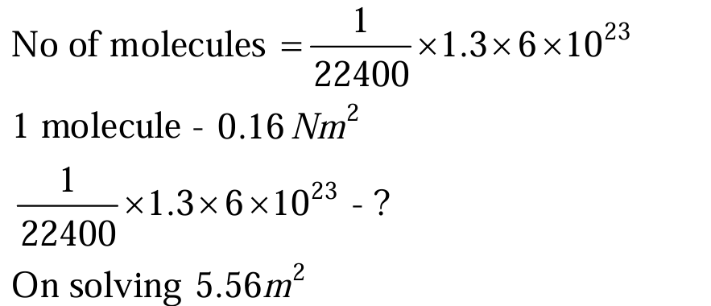

On solving

Q.13 The number of isomers possible for is

(A) 1 (B) 2 (C) 3 (D) 4

Solution : (C)

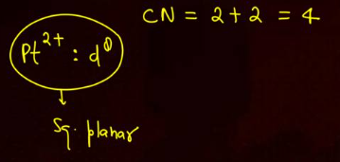

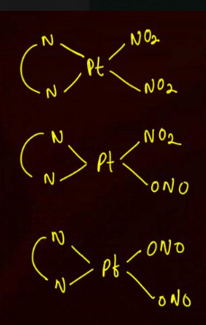

Q.14



The hybridization of compound ' ' is:

(A) (B) (C) (D)

Solution : (A)

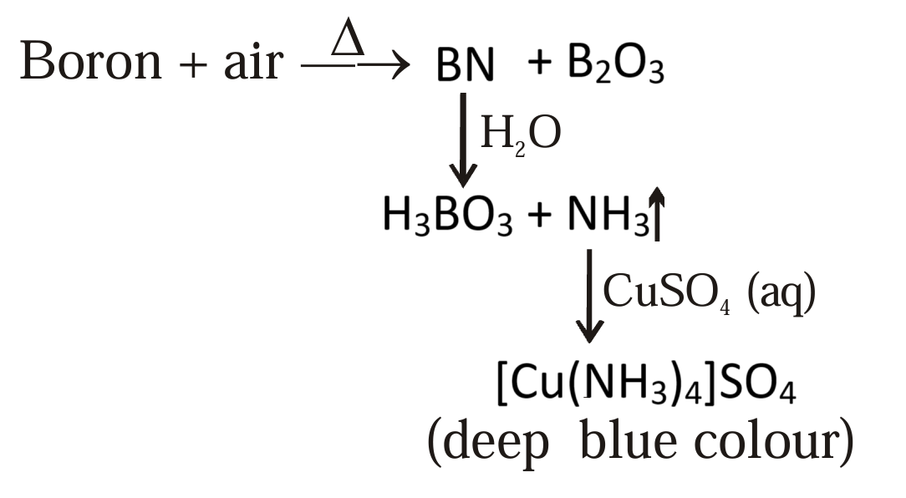

Q.15 The total number of possible structural isomers for the complex compound are

(A) 3 (B) 4 (C) 5 (D) 6

Solution : (B)

Q.16 On adding solution into KI solution, a negatively charged colloidal sol is obtained when they are in

(A) 50 ml of of 0.1 M KI

(B) 50 ml of of 0.2 M KI

(C) 50 ml of of 0.1 M KI

(D) All of these

Solution : (B)

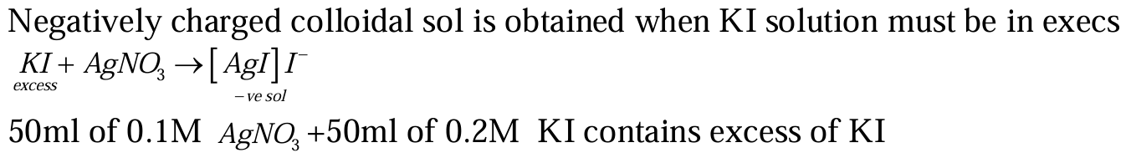

Q.17 If we arrange the following in order of magnitude of work done by the system/on the system at constant temperature then the one which will be highest is

(A) for expansion in infinite stages.

(B) for expansion in single stage.

(C) for compression in infinite stages..

(D) for compression in single stage.

Solution : (D)

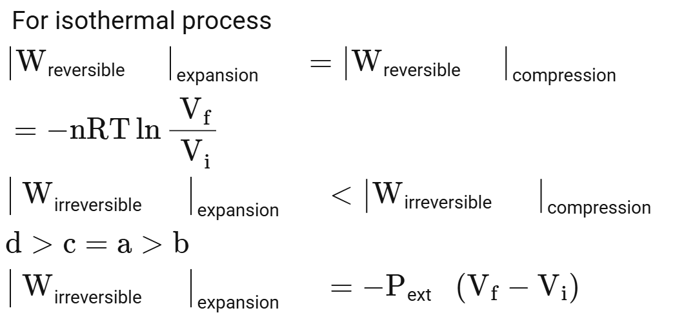

Q.18 In which of the following cases 'd' orbital without any nodal plane is used in hybridization of central atom/ion?

(A) (B) (C) (D)

Solution : (A)

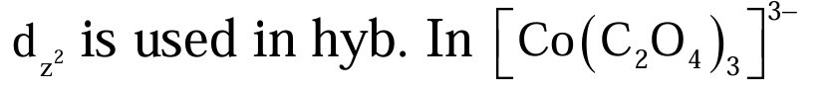

Q.19 Consider the following complexes.  
 (P)   
 (Q)

Select the correct options.

(A) Both P and Q have longer bond length than free CO molecule.

(B) P has shorter CO bond length than Q .

(C) P has longer bond length than Q

(D)

Solution : (D)

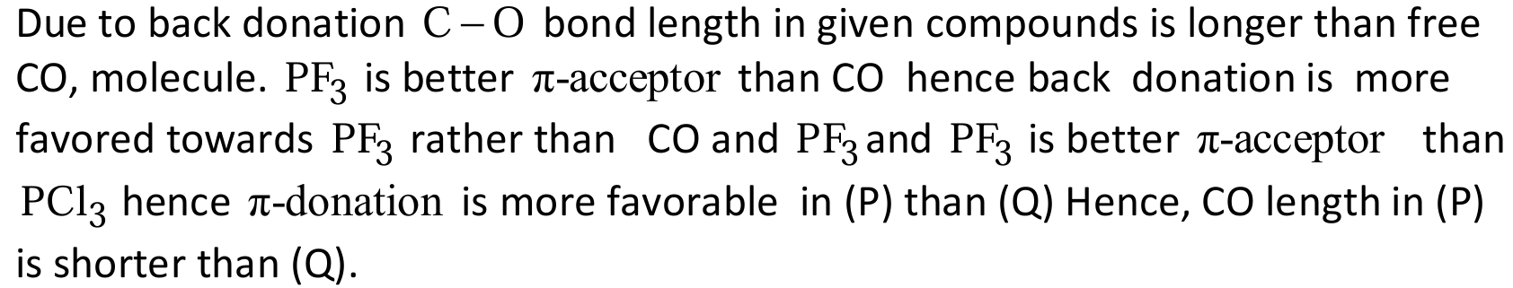

Q.20 It is an experimental fact that: salt Red precipitate Which of the following is wrong about this red precipitate?

(A) It is a non-ionic complex.

(B) It involves intra molecular H -bonding.

(C) Ni (II) is hybridized.

(D) It is a diamagnetic complex.

Solution : (C)

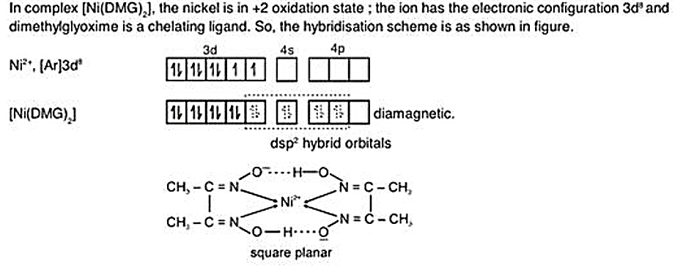

**SECTION - II**

**Numerical Type**

This section contains **5 Numerical Type questions**. **(+4, -1)**

**Answer will be between 00 to 99**

Q.21 How many of the following when treated with water or dilute acid in cold condition give

i) ii) iii) iv)

v) vi) vii) viii)

Solution : (4)

Q.22 Two complexes of chromium in have following formula and Where is a monodentate neutral ligand and is anionic bidentate ligand carrying -2 charge.  
If ratio of spin only magnetic moments of these two complexes is then Calculate

Solution : (4)

Q.23



If' is total number of all possible compounds (including stereo isomers) which can show both geometrical and optical isomerism, then find the value of ' ' ?

Solution : (8)

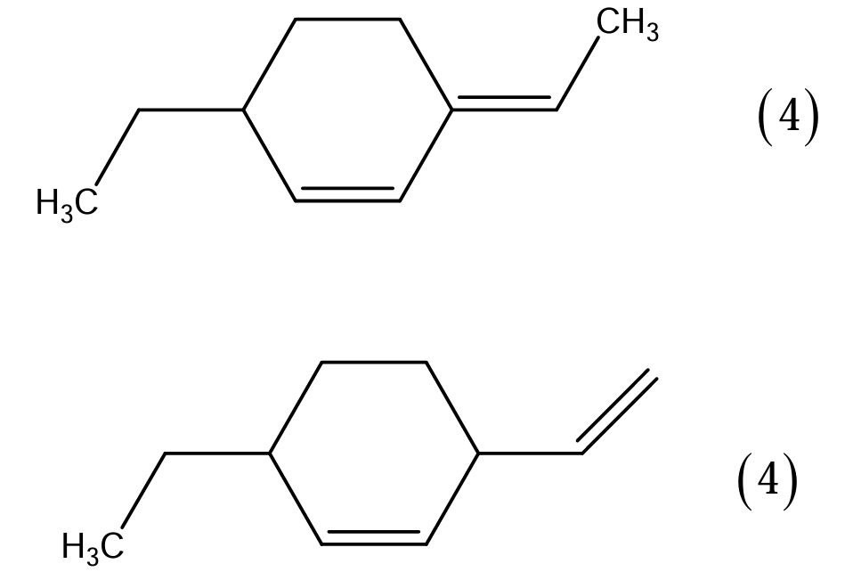

Q.24 Two cylinders “A” and “B” fitted with pistons contains equal amounts of an Ideal gas (diatomic) at 300K, the piston of “A” is free to move; while that “B” is held fixed. The same amount of heat is given to the gas in each Cylinder. If the rise in temperature of the gas is “A” is 30K. The rise in temperature of the gas in “B” is 7x what is the value of “x”

Solution : (6)

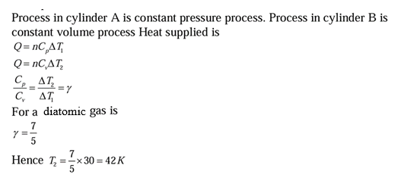

Q.25 How many geometrical isomers are possible for complex

Solution : (6)

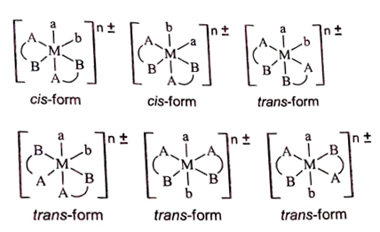

**MATHS**

**SECTION - I**

**Single Correct Answer Type**

This section contains 2**0 multiple choice questions**. Each question has four choices (A), (B), (C) and (D) out of which **ONLY ONE is correct. (+4, -1)**

Q.1 If *y* = *f* (*x*) makes +ve intercept of 2 and 0 unit *x* and *y* axes and encloses an area of 3/4 square unit with the axes then is

(A) 3/2 (B) 1 (C) 5/4 (D) -3/4

Solution : (D)

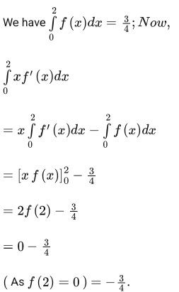

Q.2 is  
(A) 20 (B) 8 (C) 10 (D) 18

Solution : (A)

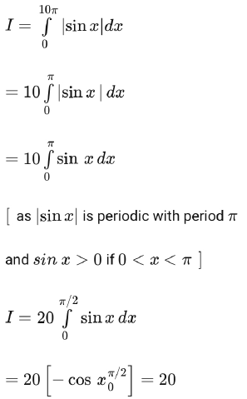

Q.3 Let for and . Then is equal to:

(A) (B) 1 (C) (D) 2

Solution : (B)

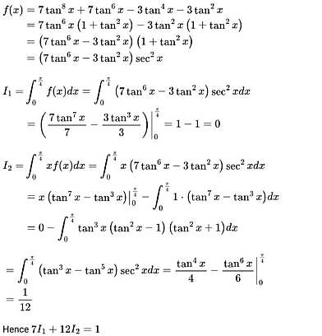



Q.4 If then is equal to  
(A) (B)   
(C) (D)

Solution : (C)

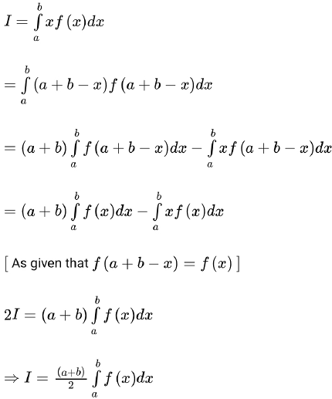



Q.5 Let *f* (*x*) be a function satisfying *f’* (*x*) = *f* (*x*) with *f* (0) = 1 and (*x*) be a function that satisfies *f* (*x*) + (*x*) = *x*2*.* Then the value of the integral

(A) (B)   
(C) (D)

Solution : (D)

Given

Integrating log

Q.6 is

(A) (B) (C) (D)

Solution : (A)

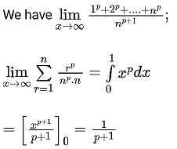

Q.7 The value of the integral *I* =

(A) (B) (C) (D)

Solution : (D)

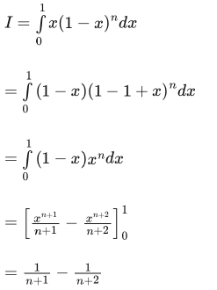

Q.8 The value of is

(A) 0 (B) 3 (C) 2 (D) 1

Solution : (D)

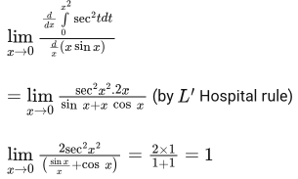

Q.9 If , then is equal to:  
(A) 9 (B) (C) (D)

Solution : (D)

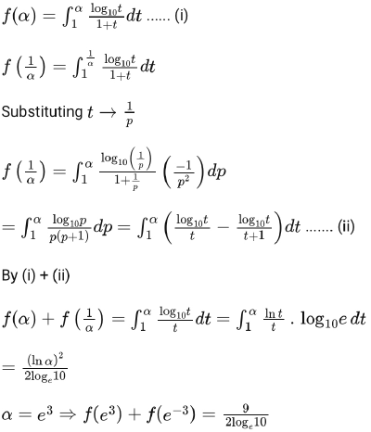



Q.10 If a curve passes through the point and the area bounded by the curve, line and axis is 8 sq units, then  
(A) (B)

(C) (D)

Solution : (A)

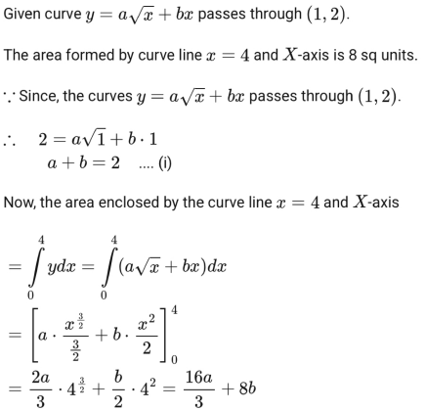



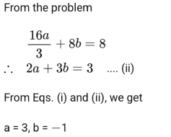

Q.11 The area (in sq. units) of the region is

(A) 30 (B) (C) 16 (D) 18

Solution : (D)

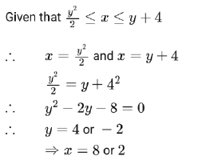

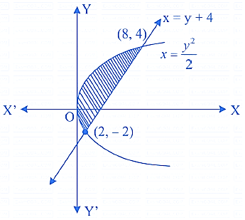

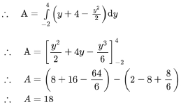

Q.12 The area (in sq. units) bounded by the curves and the line is

(A) (B) (C) (D)

Solution : (C)

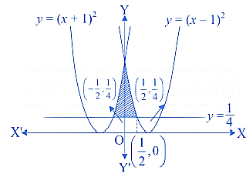

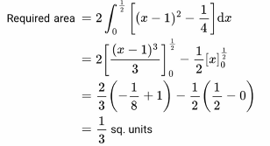

Q.13 Let be a continuous function such that for all

Let , and be the area of the region bounded by , and the axis. Then

(A) (B)   
(C) (D)

Solution : (C)

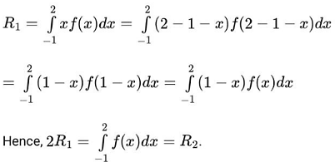

Q.14 Circle centered at origin and having radius units is divided by the curve in two parts. Then area of upper parts equals to

(A) (B) (C) (D)

Solution : (C)

Graph of circle whose centre is origin and radius is units and is

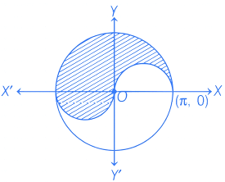

Area of shaded region Area of circle

Q.15 The area bounded by the curves and is  
(A) (B)   
(C) (D)

Solution : (D)

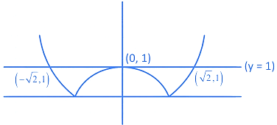

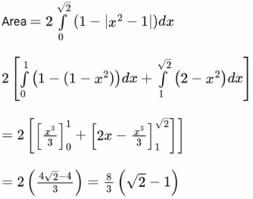

Q.16 For , let and be one of its root. Then, among the two statements  
(I) If , then cannot be the geometric mean of and   
(II) If , then may be the geometric mean of and

(A) only (II) is true

(B) Both (I) and (II) are true

(C) only (I) is true

(D) Neither (I) nor (II) is true

Solution : (B)

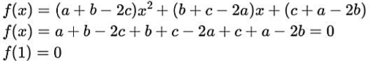

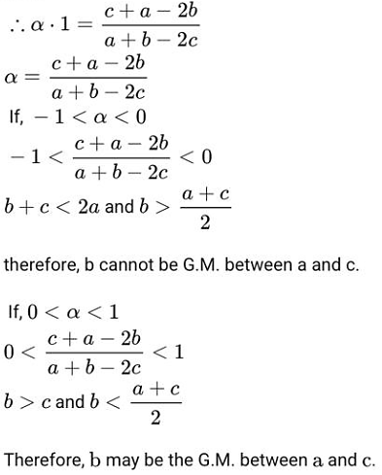

Q.17 Let . If , then the sum of all elements of the matrix is  
(A) 1 (B) 3 (C) 4 (D) 5

Solution : (D)

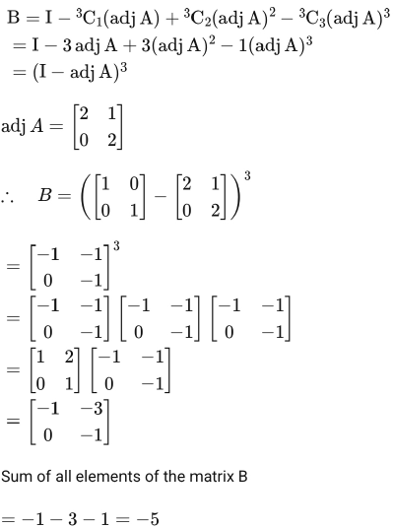

Q.18 Let . If M and N are two matrices given by and then is:

(A) a non-identity symmetric matrix

(B) a skew-symmetric matrix

(C) neither symmetric nor skew-symmetric matrix

(D) an identity matrix

Solution : (A)

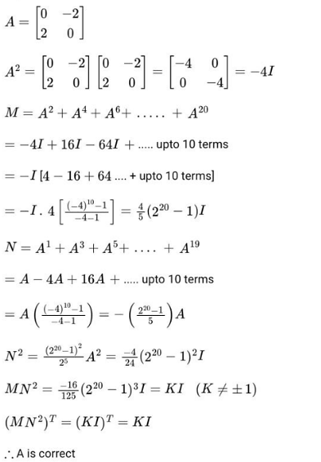

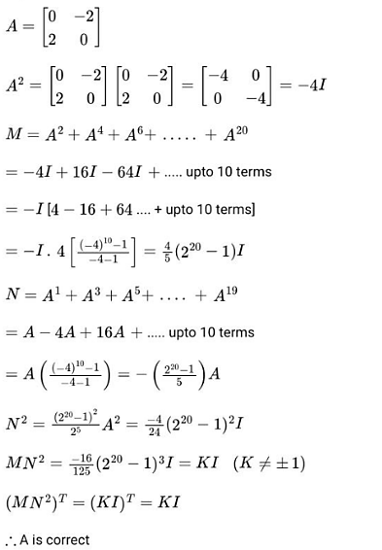

Q.19 Let be 10 observations such that and . Then the standard deviation of is equal to:

(A) 5 (B) (C) 10 (D)

Solution : (D)

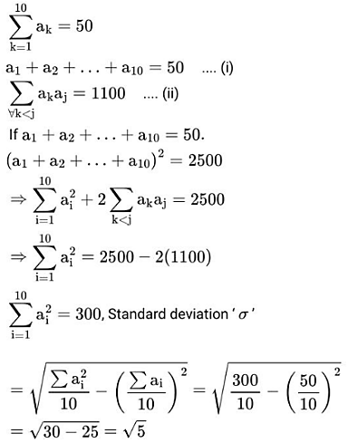

Q.20 Let and be two relation defined as follows :  
 and  
,  
where Q is the set of all rational numbers. Then:

(A) Neither nor is transitive. (B) is transitive but is not transitive. (C) and are both transitive.  
(D) is transitive but is not transitive.

Solution : (A)

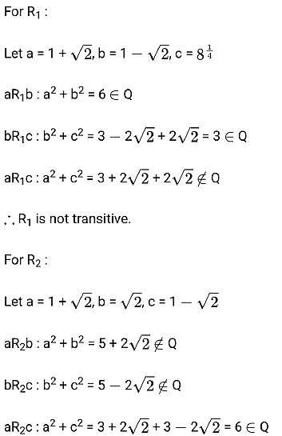



**SECTION - II**

**Numerical Type**

This section contains **5 Numerical Type questions**. **(+4, -1)**

**Answer will be between 00 to 99**

Q.21 Let denote the greatest integer . Then the value of 8. is .

Solution : (5)

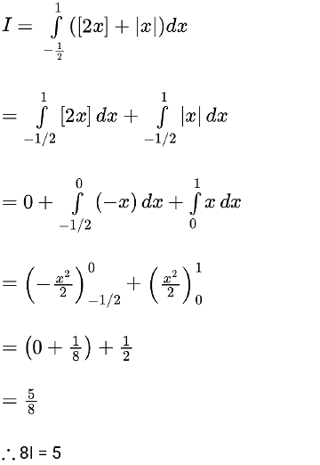

Q.22 Different A.P.'s are constructed with the first term 100, the last term 199, and integral common differences. The sum of the common differences of all such A.P.'s having at least 3 terms and at most 33 terms is .

Solution : (53)

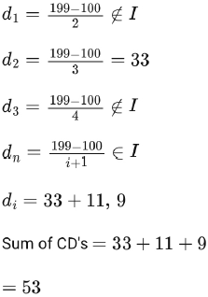

Q.23 The graphs of sine and cosine functions, intersect each other at a number of points and between two consecutive points of intersection, the two graphs enclose the same area . Then is equal to .

Solution : (64)

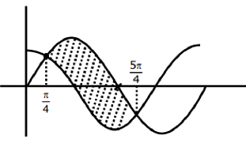

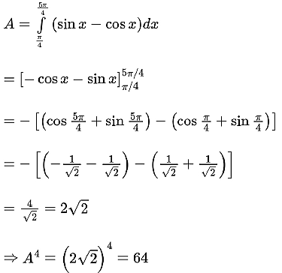

Q.24 The sum of distinct values of for which the system of equations

has non-zero solutions, is .

Solution : (3)

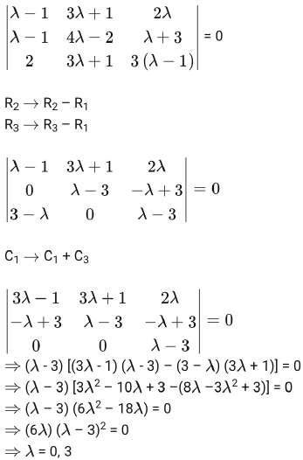



Q.25 If the mean and variance of eight numbers and be 10 and 25 respectively, then is equal to _______.

Solution : (54)

